Assignment 1: Fermat's Principle

The Fermat’s c program is attached in Email.
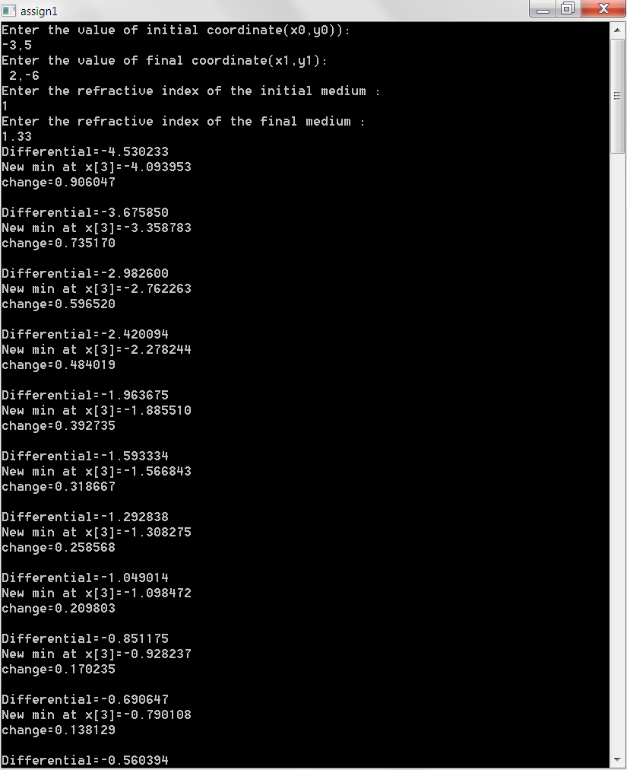
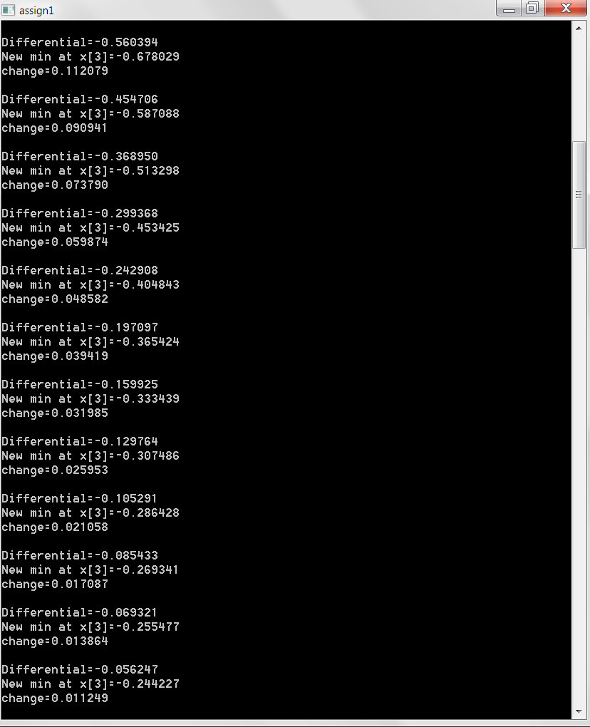
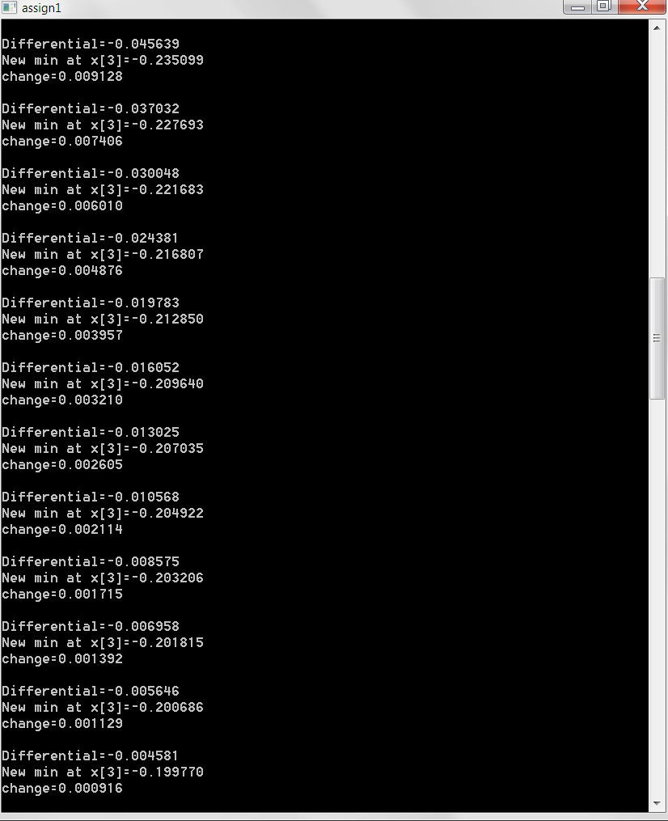
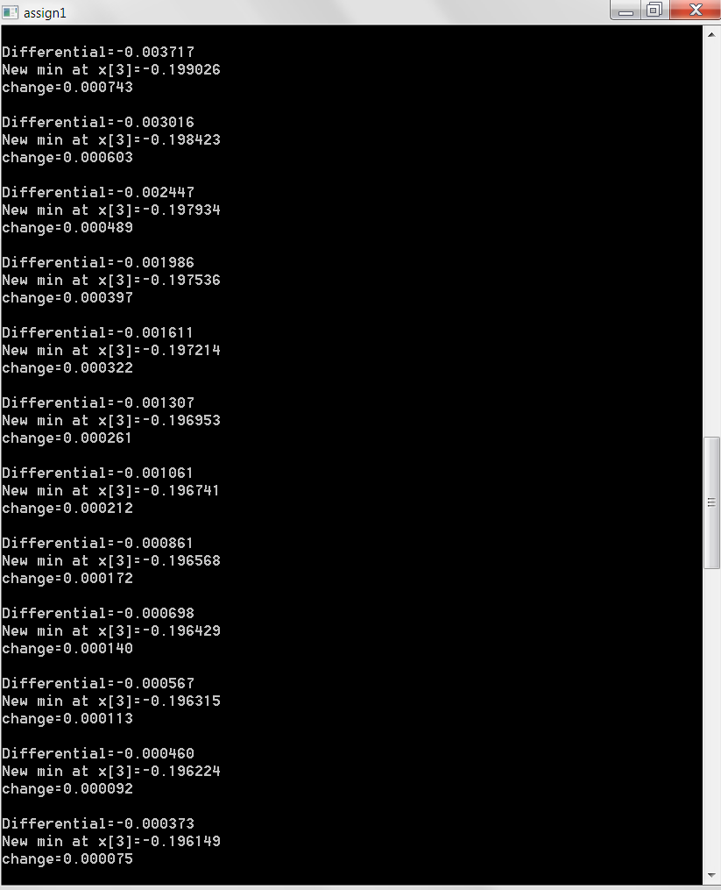
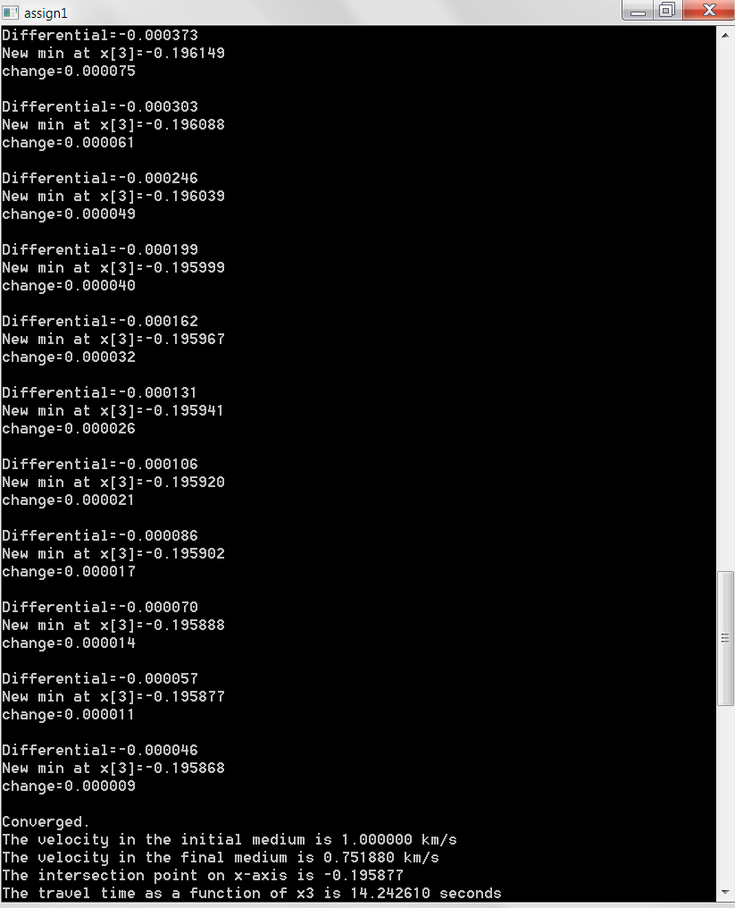
Figure1. exmaple output data of Fermat's Principle c program

From the picture, the refractive index of initial medium is 1(n1) and the refractive index of final medium is 1.33(n2). The initial coordinate is (-3,5) and final cooedinate is (2,-6).

When c=1m/s. The travel time as a function of x3 is 14.24seconds.
The intersection point on x-axis is -0.20.
From the information above, we can calculate refractive angle sinӨ1=0.49 and sinӨ2=0.34.
According to Snell’s law, n1 sinӨ1=n2 sinӨ2, so that for our result 0.49*1=0.49
0.35*1.33=0.47
0.49 >0.47 (they have 0.02 difference, there may be some errors for estimating min point by using steepest method).

